**Course: Multimedia Coding Technology**

Homework Assignment #1

Due: 18th May, 2016

**■Problems:**

(1)DCT Transformation

You are required to write a 2D-DCT transform program and apply this program to the ten 64×64 grayscale pictures shown as follows:



List the DCT coefficients of all images. The results need to be presented with images with grayscale pixel values. Additionally, you are required to analyze the energy distribution of each picture. If you want to produce the grayscale pixel values of DCT coefficients, please add each coefficient value by 128. The following picture is an example:



(2) IDCT Transformation:

Apply IDCT transformation to reconstruct ten original images from the ten DCT coefficients calculated in (1). Are they the same as the original images?

1. Please find an appropriate data type to store the data calculated from (2) and calculate the compression rate of each picture.

(4)Please handle 8x8 2D DCT transform.

In each 64x64 image, you first divide each 64x64 picture to 64 8x8 image block. Additionally, please apply 8x8 2D DCT transform to these 64 image blocks. Please use 8x8 2D IDCT transformation to reconstruct ten pictures after the following conditions, respectively.

(a)Please remain only DC of DCT coefficients.

(b)Please remain top-left 3 diagonals of DCT coefficients.

(c)Please remain top-left 6 diagonals of DCT coefficients.

(d)Please remain first 3 rows of DCT coefficients.

(e)Please remain first 3 columns of DCT coefficients.

(5)You are given a 256x256 color image, shown as following. Please divide tis 256x256 image into 256 16x16 macro blocks. In each macro block, you are required to convert RGB to YCrCb and design a sampling mechanism to remain four Y blocks, one Cr block , and one Cb block.



(6)Use the data calculated from (5) and reconstruct to the original image. Is the reconstructed image the same as the original image?

**■Grayscale Picture File Format:**

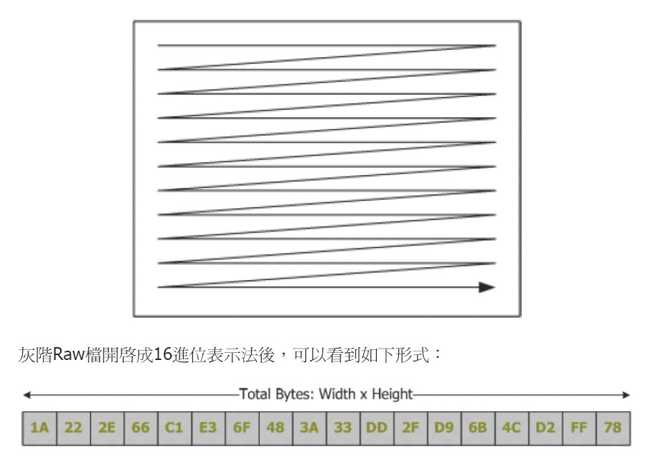

**■Color Picture File Format:**



**■File Format:**

You should upload your **source code file** and **report file**(named as HW1_491510789_張天才.doc) in ICAN. Your report file should clearly answer all questions of HW1. Additionally, printed your report file and hand in this report file to Prof. Chang’s mail box which is set in front of SF619. Any hand written report will not be accepted.